Network Communication: A 7-Layer Journey
Imagine you're downloading a new song on your phone. The process involves several steps, like how data travels across a network. These steps are defined by network protocols, which act like a common language for devices to communicate.
The OSI (Open Systems Interconnection) model, a widely used framework, defines seven layers of network protocols. Each layer performs a specific function, working together to ensure the song reaches your phone. Here's a breakdown of each layer with a real-world application example:
1. Physical Layer: This layer is like the headphone jack on your phone or the Wi-Fi signal from your router. It defines the physical characteristics of the network connection, such as cables or wireless signals.
a. Function: Transfers raw bits over a physical medium.
b. Example: Ethernet cables, Wi-Fi signals.
c. Daily Life: Connecting your computer to the internet via an Ethernet cable or Wi-Fi.
2. Data Link Layer: Imagine addressing the data packets (containing the song) to your phone's MAC address. This layer handles sending and receiving data packets over the physical layer and ensures they arrive at the correct network interface card (NIC) in your phone (like delivering the packets to the right house on your street).
a. Function: Handles error detection and correction from the physical layer.
b. Example: MAC addresses.
c. Daily Life: Ensuring your Wi-Fi connection is stable and free of errors by addressing the data packets to your device.
3. Network Layer: This layer is like the internet service provider (ISP) that routes the data packets containing the song across the vast network. It determines the most efficient route for the packets to travel from the music streaming service's server to your phone's ISP (like choosing the fastest route for delivery).
a. Function: Determines how data is sent to the recipient’s address.
b. Example: IP addresses.
c. Daily Life: Routers directing traffic on your home network to find the most efficient path.
4. Transport Layer: Think of this layer as the music streaming app on your phone. It ensures reliable delivery of the song by breaking it into smaller packets (like verses and choruses), sending them, and reassembling them correctly on your phone (like the delivery person ensuring all parts of your package arrive). The Transport Control Protocol (TCP) is commonly used here for reliable, in-order delivery.
a. Function: Ensures complete data transfer.
b. Example: TCP, UDP.
c. Daily Life: Ensuring a file download is complete and accurate.

5. Session Layer: This layer is like establishing a connection with the music streaming service to download the song. It manages the communication session between your phone's app and the service's server (like coordinating with the store to ensure they have your order ready).
a. Function: Manages sessions between applications.
b. Example: APIs managing sessions in web services.
c. Daily Life: Staying logged into a website while browsing.
6. Presentation Layer: Like how the music streaming service might compress the song file for faster download, this layer prepares the data for the application layer. It handles data compression, encryption, and decryption.
a. Function: Translates data into a format the application can accept.
b. Example: Encryption and decryption, data compression.
c. Daily Life: Viewing a secure web page using HTTPS.
7. Application Layer: This is where you finally get to listen to the song! This layer provides the interface for applications (like your music streaming app) to access network services. Protocols like HTTP (Hypertext Transfer Protocol Secure - the secure version for encrypted communication) are used here.
a. Function: Provides network services directly to the user.
b. Example: HTTP, FTP, SMTP, WebSocket
c. Daily Life: Using a web browser to access a website (HTTPS), transferring files (FTP), sending emails (SMTP), real-time applications like chat (WebSocket).
Flow Diagram:
+-------------------------+ (Application Layer)
| Music Streaming App | -----> Song Request (HTTP)
+-------------------------+
|
v
+-------------------------+ (Presentation Layer)
| Data Compression | -----> Compressed Song Data
+-------------------------+
|
v
+-------------------------+ (Session Layer)
| Session Establishment | -----> Establishes Connection
+-------------------------+
|
v
+-------------------------+ (Transport Layer)
| Song Segmentation | -----> Breaks song into Packets (TCP)
+-------------------------+
|
v
+-------------------------+ (Network Layer)
| Routing | -----> Finds Best Path (IP)
+-------------------------+
|
v
+-------------------------+ (Data Link Layer)
| Error Detection | -----> Adds Error Checking (MAC)
+-------------------------+
|
v
+-------------------------+ (Physical Layer)
| Wi-Fi Transmission | -----> Sends Packets over Wi-Fi
+-------------------------+
|
v
+-------------------------+ (Receiver - Music Service)
| Processing |
+-------------------------+
|
v (The process repeats in reverse order for each packet)
+-------------------------+ (Receiver - Music Streaming App)
| Song Reassembly | -----> Reassembles Packets into Song
+-------------------------+
|
v
+-------------------------+ (Application Layer)
| Music Playback | <---- You hear the song!
+-------------------------+
Song on Spotify:
+-------------------------+ (Application Layer - Spotify App)
| User searches "Believer"| -----> Song Request (HTTP)
+-------------------------+
|
v
+-------------------------+ (Presentation Layer)
| Data Compression | -----> Compressed Song Data (Optional)
+-------------------------+
|
v
+-------------------------+ (Session Layer)
| Establishes Connection | -----> Connects to Spotify Server
+-------------------------+
|
v
+-------------------------+ (Transport Layer)
| Song Segmentation | -----> Breaks song into Packets (TCP)
+-------------------------+
|
v
+-------------------------+ (Network Layer)
| Routing | -----> Finds Best Path to Spotify Server (IP)
+-------------------------+
|
v
+-------------------------+ (Data Link Layer)
| Error Detection | -----> Adds Error Checking (MAC)
+-------------------------+
|
v
+-------------------------+ (Physical Layer)
| Wi-Fi Transmission | -----> Sends Packets over Wi-Fi
+-------------------------+
|
v
+-------------------------+ (Spotify Server)
| Receives Packets |
+-------------------------+
|
v
+-------------------------+ (Server-side Processing)
| Verifies & Reassembles | -----> Reassembles & Processes Song Data
+-------------------------+
|
v
+-------------------------+ (Server sends data back)
| (The process repeats in reverse order for remaining packets)
+-------------------------+
|
v
+-------------------------+ (Phone receives data)
| Decodes & Buffers | -----> Decodes & Stores Downloaded Song Data
+-------------------------+
|
v (Playback starts when enough data is buffered)
+-------------------------+ (Application Layer - Spotify App)
| Plays Song | <---- You hear "Believer" by Imagine Dragons!
+-------------------------+

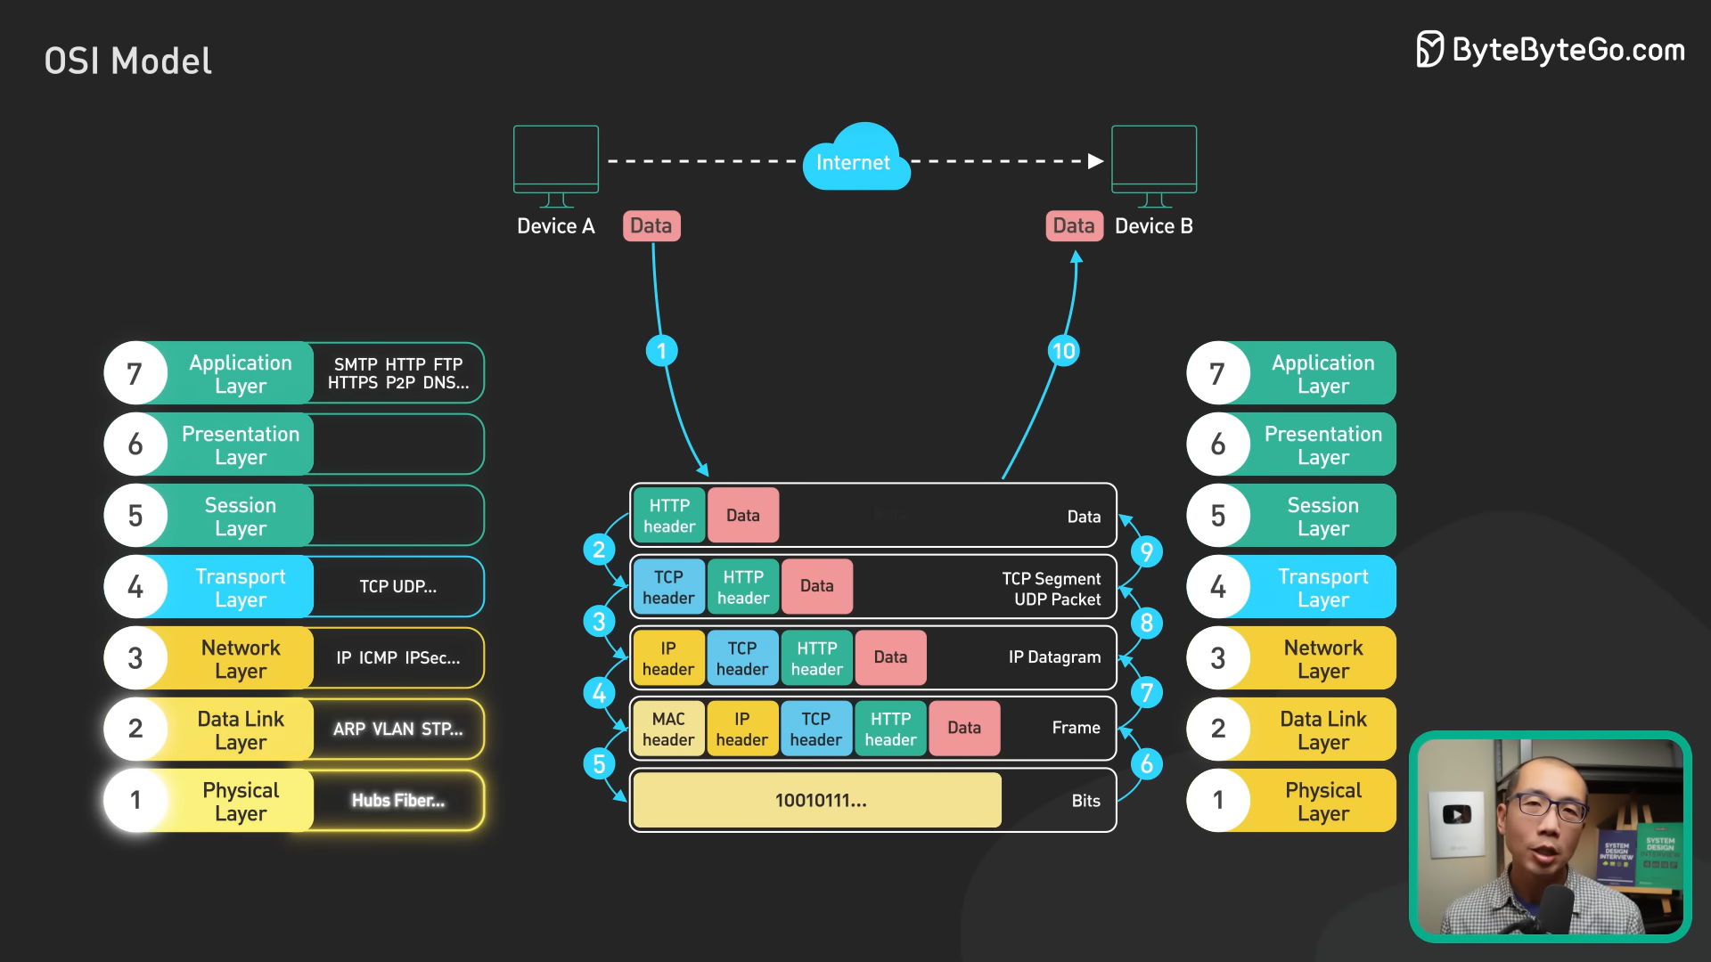

Deep Dive: Application and Transport Layers with Explanations and Diagrams
Application Layer - A Rich Ecosystem of Protocols
The application layer sits closest to the user and interacts directly with applications. Here's a breakdown of some key application layer protocols and their uses, along with diagrams for better understanding:
- SMTP (Simple Mail Transfer Protocol): Imagine you're composing an email on your phone. SMTP acts behind the scenes, securely transferring your email message (like the content of the email) between email servers (like the servers of your email provider and the recipient's provider) to ensure it reaches the intended recipient.
- WebSocket: Think of having a live chat conversation with a friend about planning a movie night. WebSocket enables real-time, two-way communication between your web browser and the movie streaming service's server. This allows for instant back-and-forth messages, ideal for applications like chat, online collaboration tools, or live feeds (unlike regular web browsing, where you refresh the page to see updates).

Diagrams:
- SMTP (Email Delivery):
[Client (Email App on Phone)] -> (SMTP) -> [Email Server 1 (Sender)] -> (SMTP) -> [Email Server 2 (Receiver)] -> (SMTP) -> [Client (Email App on Recipient's Device)]
- WebSocket (Live Chat):
[Client (Web Browser)] <-> (WebSocket) -> [Movie Streaming Service Server] <-> (WebSocket) -> [Client (Web Browser of your Friend)]
HTTPS vs HTTP and FTP - Security and File Transfer Considerations
- HTTPS (Hypertext Transfer Protocol Secure): This is the secure version of HTTP, like encrypting your credit card information when you shop online. HTTPS encrypts data transmission, protecting sensitive information like credit card details during online transactions (unlike HTTP, which is not secure for confidential data). HTTP is still used for some non-sensitive data transfers within websites, but the trend is towards using HTTPS for increased security.
- FTP (File Transfer Protocol): While FTP is a common file transfer protocol, it's not as widely used for web applications as HTTP. Imagine downloading a large software update for your phone. FTP is a specialized protocol used for transferring large files directly between computers, whereas HTTP handles data exchange within web pages.
Note: Being replaced by more secure protocols like SFTP.
TCP vs UDP - Explained with Diagrams:
TCP (Transmission Control Protocol):
Imagine downloading a new song on your phone. TCP guarantees reliable data delivery by:
- Segmenting data: Breaking the song file into smaller, manageable pieces (packets).
- Numbering packets: Assigning a sequence number to each packet.
- Error checking: Using checksums to detect errors in received packets.
- Acknowledgement (ACK): Sending an ACK signal to confirm receipt of a packet.
- Retransmission: Resending packets that are lost or corrupted.
Here's a diagram illustrating TCP data flow:
[Client (Music App)] -> (Packet 1) -> [Network] -> (Packet 1) -> [Server]
<- (ACK) <- [Network] <- (ACK) <- [Server]
[Client (Music App)] -> (Packet 2) -> [Network] -> (Packet 2) -> [Server]
<- (ACK) <- [Network] <- (ACK) <- [Server]
-> (Packet 2 lost) -> [Network] -> (Packet 2 lost)
<- (ACK) <- [Network] <- (ACK) <- [Server]
[Client (Music App)] -> (Packet 3) -> [Network] -> (Packet 3) -> [Server]
<- (ACK) <- [Network] <- (ACK) <- [Server]

UDP (User Datagram Protocol):
Imagine streaming a live sports game on your phone. UDP prioritizes speed over reliability:
- Datagram creation: The video and audio data are encapsulated in datagrams (packets) without segmentation or sequencing.
- Datagram transmission: The datagram is sent directly to the destination.
- No error checking or retransmission: Unlike TCP, UDP doesn't check for errors or resend lost packets. This allows for faster transmission, but occasional glitches or dropped frames might occur in the video stream.

Here's a diagram illustrating UDP data flow:
[Client (Streaming App)] -> (Datagram) -> [Network] -> (Datagram) -> [Streaming Server]
Choosing TCP vs UDP:
- Use TCP for applications that require guaranteed, in-order delivery, like downloading files or making video calls (ensuring all data arrives complete and in the correct order for a smooth experience).
- Use UDP for real-time applications where occasional data loss is acceptable, like online gaming or streaming (tolerating a glitch

